**CEN 4010 Principle of Software Engineering, Spring 2018**

*Team Name: Grupo Fivo*

*Team 5*

**Neil Maniquis**

nmaniquis2017@fau.edu

**Noah Leach**

nleach2013@fau.edu

**Diego Segura**

dsegura2015@fau.edu

**George Bechtel**

gbechtel2013@fau.edu

**Franklin Carrillo**

fcarrillo2012@fau.edu

**Date: 4/11/18**

**Revision Table**

|  |  |
| --- | --- |
| **Date** | **Description** |
|  |  |
|  |  |
|  |  |

**1 Purpose of this Milestone:**

Milestone 4 is Beta launch of you “product” (or its substantial part). The purposes of

this milestone are as follows:

1) To focus the teams on launching the first iteration of the final delivery

software to a “limited customer set” (e.g. instructors and selected friends)

and to make final commitment for functions to be delivered (e.g. list of

Priority 1 functions)

2) To check that all required non-functional specs are satisfied or on track

3) To practice formal usability test plan development

4) To practice formal QA test

5) To practice code review

6) To ensure that basic practices of secure software are applied

**2 Content and structure of this Milestone**

**2.1 Title pageDONE**

Note: The following items are examples. You can modify my item list, but you need

to have a nice, neat and well-designed cover page:

1) Course name and term (e.g., CEN 4010 Spring 2018) Milestone 4 Beta Launch

and Reviews

2) Your project/application title and name (you can use the name you chose for

your application)

3) Team number

4) Names of students and team members roles, for example, Scrum Master,

Product Owner, Develop Team, and their emails

5) Date of the document

6) Revision history table. Note: you will update this document based on

instructor’s feedback so this is important.

**2.2 Product summary**

For example, how would you market your product. Write it for wider audience: for

example, executives, marketing, and customers. Maximum ¾ page.

2

1) Name of the product

2) Explicit list of ALL major committed functions. These are your FINAL Priority

1 functions for which you will be graded and that your team shall actually

deliver and test for. You should use plain English as if you would talk to a

customer, and not the language used for formal requirements specification.

This is your FINAL functional commitment. In other words, failure to deliver

on some of Priority 1 functions will result in reduced grade. Please write it in

the list format (each item max 1-3 lines) so it is easy to check.

3) Describe unique features in your product (if any)

4) URL to your product accessible to instructors, on deployment server

The list of final functions will be checked on your final delivery for functionality and

correct operation as you specified them. Failure to deliver complete list of these

committed functions may result in reduced grade.

**2.3 Usability test plan – maximum 2 pages**

Select ONE major function (NOT login or registration) to be tested for usability. We

recommend search or upload/post.

Write a usability test plan for this selected function. Please consult class material on

developing usability test plan and questionnaire. This test plan is to contain:

1) Test objectives: 0.5 page

2) Test plan: System setup, starting point, task to be accomplished, who is the

intended user, completion criteria, URL of the system to be tested. 3/4 page

3) Questionnaire form: 3 Lickert scale questions, in a form easy to be used by

reviewer (check class slides). 3/4 page

Your test plan must be formatted to be easy to read and use by usability testers,

including the questionnaire.

You can also ask your friends or team members to do the usability test.

**2.4 QA test plan – maximum 2.5 pages**

For the same function you chose for the usability test, write AND execute a QA test

plan (check class slides)

a) Create formal QA test plan (consult QA class material). Basically, it has to contain:

1) Test objectives: max 0.5 pages

2) Hardware and software setup: max 0.5 page

3) Feature to be tested: max 0.5 page

4) Actual test cases: 3 test cases and results of testing them on your system: 1

page

3

You must provide test plan and test summary in the format (e.g. form) allowing easy

reading and analysis by management e.g. in a table format like presented in the

lecture.

Suggested format for QA Table columns are: test #; test title; test description; test

input; expected correct output; test results (PASS or FAIL for each tested browser)

5) Perform the testing as per plan above and record the results in a form above.

6) Apply the above test on 2 browsers of different type and record it in the

above table

**2.5 Code Review**

By now you should have chosen a coding style. In the report state what coding style

you chose.

Chose the code (substantial portion of it) related to the feature you used for QA and

usability test. You need to submit an example of the code (or part of it – 2 pages or

so MAX) for its function to be peer reviewed, and document this as follows:

1) One team member should submit code to other team member(s) for peer

review.

2) Peer review should be performed by other group member(s) (1 review is

OK).

3) Peer review is to be done by e-mail and comments are to be included in the

code

4) Submit listing containing the peer review and commented code and

communication related to this in your Milestone 4 document

Important: It is critical that code reviews are friendly and helpful, intended to help

and education, and not to criticize. It is strongly suggested that you use peer review

in the development of the whole system.

**2.6 Self-check on best practices for security – ½ page**

1) List major assets you are protecting

2) Confirm that you encrypt password in the DB

3) Confirm Input data validation (list what is being validated and what code you

used) – we request that you validate search bar input;

**2.7 Self-check: Adherence to original Non-functional specs**

Copy all original non-functional specs as in high level application document

published at the very beginning of the class and then for each say **DONE** if it is done

(which is expected and required); **ON TRACK** if it is in the process of being done and

you are sure it will be completed on time; or **ISSUE** meaning you have some

problems and then explain it.

4

Note: you must adhere to all original non-functional specs as published in the

original high-level specification document. Failure to do so may cause reduced grade

**3 Submission**

Team lead submit Milestone 4 document to Canvas by due date

**4 Grading criteria**

Your document needs to be well-written, well-organized (formatted) and reads well.

Grading is based on cohesiveness

1. List of Non-Functional Requirements

1. Ability to go to any item page from the homepage within 1 minute -DONE

2. Ability to create a new user account under 5 minutes –ON TRACK

3. Ability to add a new item for sale under 8 minutes –ON TRACK

4. Ability to update the inventory of 10 items in under 5 minutes –ISSUE – Requirement is related to a non-committed function

5. Passwords are not stored in plaintext and identical passwords will be stored differently for different users -Done

6. Usability of website for customer on a mobile device should be within 1 minute of desktop experience –ON TRACK

1. **Self-check on best practices for security**
2. List major assets you are protecting

Emails, passwords, product information, order history, class history

1. Confirm that you encrypt password in the DB

Passwords are encrypted using

password_hash($password, PASSWORD_DEFAULT);

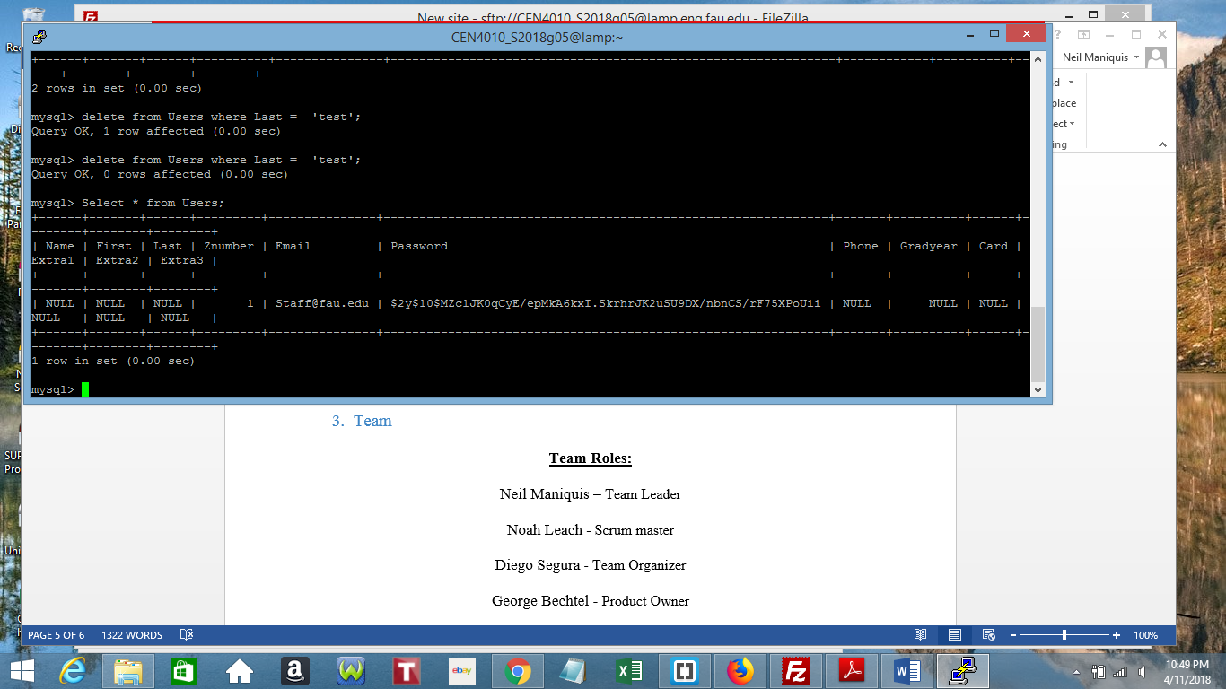

3) Confirm Input data validation (list what is being validated and what code you

used) – we request that you validate search bar input;

Data obtained through textboxes are passed through htmlspecialchars()

$email = $_POST[htmlspecialchars("email")];

Accessing the DB is done through prepared statements

$sql = $conn->prepare("SELECT Products FROM Keyword WHERE Keyword = :Keyword ");

$sql->bindParam(':Keyword', $wildcardfindtxt);

$sql->execute();

1. Team

**Team Roles:**

Neil Maniquis – Team Leader

Noah Leach - Scrum master

Diego Segura - Team Organizer

George Bechtel - Product Owner

Franklin Carrillo - Web developer